Minutes

REGULAR MEETING

^{Wed., January 4, 2017}

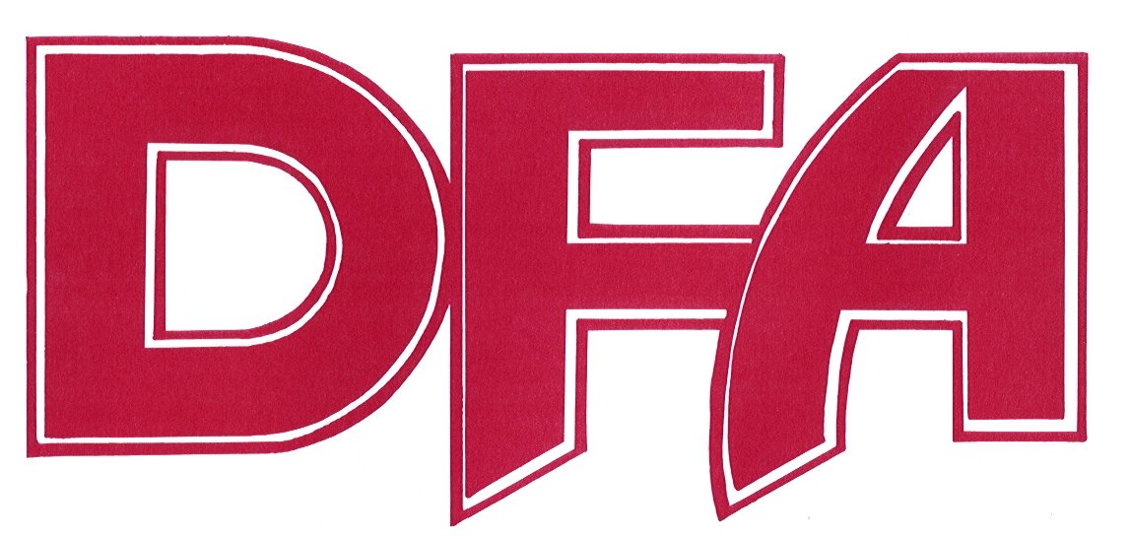
Dundas Federation of Agriculture

Location: Agricultural Hall, Nelson LaPrade Centre – Chesterville

Time: 8:00 p.m.

Present: Deborah Patenaude, William Martens, Jon Roosendaal, Tom MacGregor
Stephen Mellon, Ron Wilson, Bernard VanderZweep, Ryan DeVries
Warren Schneckenburger, Jacqueline Kelly-Pemberton, Mary Dillabough

1. Welcome & Introductions: Jacqueline Kelly-Pemberton – Chair

2. Agenda Approval:
M/S – Jon Roosendaal, Tom MacGregor (Carried).

3. Approval of Minutes:
M/S – Tom MacGregor, Deborah Patenaude (Carried).

4. Business from Minutes:
a) Proud to Lead funding has been received.

b) Letter of School Support
Marty was not in attendance to update the group on the status of the letter. Jackie will follow-up.
A special SD council meeting on this issue is being held in the SD Council chambers tomorrow night. Another meeting is being planned, Ron will forward the details.

5. New Business:
a) AGM Date
Wed., March 8 was chosen as our annual AGM date. Suggestions for guest speakers were the new presidents of the OFA and SNC. The regular March 1 meeting will still be on.

6. Correspondence:
Jackie was pleased to read a letter of support from SD regarding change to Tax Treatment of On-Farm
Value-Added Activities. Jackie and Bernie had previously made a presentation to council on Farm Assessment which influenced the council to write the letter of support.

7. President’s Report:
a) Forest Cover – SNC
SNC has established a working group to look at the loss forest cover. It will be made up of municipal reps and members of the agricultural community. Jackie will chair and the DFA President and PAC member will also be on this committee. $100,000 has be made available from a municipal levy. Most of these funds will be used to implement the recommendations made and a small portion for administration costs. The first order of business is the establish Terms of Reference and a Mandate. They are hoping to have a report by the end of March.

b) Farmer’s Gala
The Gala is being held March 25th at the Joel Steele Community Centre. AJs has been booked as the caterer and will be serving chicken as the entrée. The theme will be the 150th anniversary for Canada. The inductees to the new Ag Hall of Fame will be announced and funds raised will be going to the
Food Bank.

c) Rent Question
A DFA member contacted Jackie recently and wanted to know what rental cost for tiled land was. The board members agreed that $160-$170 per acre was reasonable, but this figure could change depending on the location of the land and vicinity to the renter’s farm.

d) SD Council Presentation
Jackie will be making a presentation the SD council at their meeting, Jan 17th, prior to the final budget deliberations. The topic is the impact MPAC assessments and farm tax rates. Another presentation will be made to ND at a later time as their budget has already been completed.

8. PAC Report
Bernie gave a short presentation on the American Dream in Agriculture. The US ecomony is on the comeback while reducing greenhouse gases and increasing exports. He explained that Costco will be opening a large new plant in Nebraska to process their chickens. He feels that the US government supports their farmers by paying them to implement green processes such as buffer strips etc. Something that our government should consider.

Another issue on his mind is the SPCA. The fines for farmers have increased and jail time is possible. He wondered whether you can sue the SPCA for wrongful charges. More details are needed and Bernie will continue working on this and possibly drafting a resolution.

9. Director’s Report – Nothing to report.

10. MSR Report – See Attached.

11. Motion to adjourn – Deborah Patenaude

